**Personal Assistant For Seniors Who Are Self-reliant**

**Using IoT**

A Project report submitted in partial fulfilment of 7th semester in degree of

**BACHELOR OF ENGINEERING**

**IN**

**COMPUTER SCIENCE AND ENGINEERING**

**Submitted By**

**Team ID :PNT2022TMID49884**

NAGARAJAN K (950619104043)(Member)

PRASANTH G (950619104048)(Team Leader)

SURESH R (950619104068)(Member)

MASANAM M (950619104039)(Member)



**DEPARTMENT OF COMPUTER SCIENCE AND ENGINEERING**

**EINSTEIN COLLEGE OF ENGINEEING,**

**TIRUNELVELI-627 012**

**BONAFIDE CERTIFICATE**

Certified this Report **“Personal Assistant For Seniors Who Are Self Reliant(Medicine Reminder)”,** for the project, is the Bonafide work of **“NAGARAJAN K (950619104043)(Member)”. “PRASANTH G (950619104048)(Team Leader)”. “ SURESH R (950619104068)(Member) “. “ MASANAM M (950619104039)(Member) “** who carried out the project work under my supervision. Certified further that to the best of my knowledge the work reported here in does not form part of any other thesis or dissertation on the basis of which a degree or award was co-offered on the earlier occasion on this or any other candidate.

**SIGNATURE SIGNATURE**

**Dr. T.SURESH THANKRISHNAN S.JEYAMARY**

**HEAD OF THE DEPARTMENT MENTOR**

**COMPUTER SCIENCE AND ENGINEERING COMPUTER SCIENCE AND ENGINEERING**

**EINSTEIN COLLEGE OF ENGINEEING EINSTEIN COLLEGE OF ENGINEERING**

**TIRUNELVELI-12 TIUNELVELI-12**

**ACKNOWLEDGEMENT**

We have successfully completed the project with blessings showered onus by god, the almighty, A project of this nature needs co-opreation and support from many for successful completion.We express our heartfelt thanks to Mr.A.MATHIVANAN, BE., M.sc.,(Agri),Managing Trustee of Einstein college of Engineering, Tirunelveli, for his mortal support and device.Our thanks to Prof.A.AMUTHAVANAN, BE., M.S (USA).B.L,Chairman of our college for making necessary arrangements to do this project.Our heartly thanks to Prof.EZHILVANAN, MBA., Secretary of our college for making necessary arrangements to do this project.We wish to express our gratitude to Dr.VELAYUTHAM,M.E,Ph.D.,FIE. Principal for the support he provided us to carry out this project successfully.We are very much thankful to Dr. T.SURESH THANKRISHNAN, Head of the Department , Electronics and communication Engineering who is always a constant of inspiring us.We are extend our sincere thanks to all teaching and non-teaching staff members and our family members, friends for their help in completing this project.

**ABSTRACT**

In the contemporary day life style people have no time to spend with their family.In such a busy life it‘s difficult to keep an isolated day out of their busy schedule for the doctor for consistent medical checkup and taking medicines at time.Their is a necessity for new idea and technology which helps in saving their time. The proposed model enables users to improve health related risks and reduce healthcare costs by reminding to take medicines at time,collecting,recording and analyzing data in real time efficiently. With the help of this proposal the time of both patients and doctors are saved and doctors can also help in emergency scenario as much as possible.The proposed outcome of the project is to give proper and efficient medical services to patients by remiding them when to take medicines and collecting data information

**TABLE OF CONTENTS**

**Chapter No Title Page No**

**1. INTRODUCTION 7**

**1.1 Project Overview 7**

**1.2 Purpose 9**

**2. LITERATURE SURVEY 10**

**2.1 Existing problem 10**

**2.2 References 11**

**2.3 Problem Statement Definition 12**

**3. IDEATION & PROPOSED SOLUTION 13**

**3.1 Empathy Map Canvas 13**

**3.2 Ideation & Brainstorming 14**

**3.3 Proposed Solution 16**

**3.4 Problem Solution fit 17**

**4. REQUIREMENT ANALYSIS 18**

**4.1 Functional requirement 18**

**4.2 Non-Functional requirements 18**

**5 PROJECT DESIGN 22**

**5.1 Data Flow Diagrams 22**

**5.2 Solution & Technical Architecture 23**

**5.3 User Stories 24**

**6 PROJECT PLANNING & SCHEDULING 25**

**6.1 Sprint Planning & Estimation 25**

**6.2 Sprint Delivery Schedule 26**

**6.3 Burndown Char 26**

**7 CODING & SOLUTIONING 28**

**7.1 Feature 1 28**

**7.2 Feature 2 28**

**8. TESTING 29**

**8.1 Test Cases 29**

**8.2 User Acceptance Testing 31**

**9. RESULTS 33**

**9.1 Performance Metrics 33**

**10. ADVANTAGES & DISADVANTAGES 35**

**11. CONCLUSION 36**

**12. FUTURE SCOPE 37**

**13. APPENDIX 38**

**Source Code 38**

**GitHub & Project Demo Link 44**

**LIST OF FIGURES**

**FIG.NO FIG.NAME. PAGE.NO**

3.1.1 Empathy map canvas 13

3.2.1. Brain Storming 14

4.2.1 Arduino Uno R3. 19

4.2.2 LED. 19

4.2.3 Resistor. 20

4.2.4 LCD 16x2. 20

4.2.5. Piezo. 21

4.2.6 Positional Micro Servo. 21

5.1.1 Data flow diagrams 22

5.2.1 Technical Architecture. 23

5.3.1 User Stories 24

6.1.1. Sprint Planning & Estimation. 26

6.2.1 Sprint Delivery Schedule. 26

6.3.1 Burndown Chart. 27

**CHAPTER 1**

**INTRODUCTION**

Patient monitoring and management in critical care environments such as the ICU‘s ,. SICU‘s and ANCU‘s involve estimating the status of the patient and reacting to events that may be life threatening. It is impossible to keep a tab on every patient throughout the day. New solutions are needed in this field to help the doctors and the nursing staff to monitor the patients. A critical element of this is the medicine administration and monitoring. This has been achieved by the patient medicine reminder system. This system consists of Arduino, GSM Module, RTC Module. This system is driven by an program that inputs predefined parameters which is processed based on the input variables entered via a user interface device such as the PC. The logic for the processing Is built into the embedded program to initiate the alert through an audio alarm. Not only does it have an alarm system, but also gives indication when medicine is not taken at the reminder time.

* 1. **Project Overview**

Sometimes patients forget to take the medicine at the required time of medicines. And sometimes patient also forgets which medicine He/She have to take at required time. And it is difficult for Doctor/Compounder to monitor patients around the clock. To avoid this problem, we have made this **medicine reminder system for patients using**[**Arduino**](https://www.engineersgarage.com/articles/arduino)**.** In this system we have used Arduino for controlling the whole system. Working of this project is very simple. In this system **ds1307 real time clock chip** is used for running the time accurate and to prevent the time after light failure by using **3 volt li-on battery** connected with this real time clock chip at pin number 3.**SDA** and **SCK** pin of real time clock chip is directly connected with **SDA** and **SCK** pin of Arduino (**A5** and **A4**) respectively. These two pins should be pull-up using 10K resistor. When we start this system real time clock runs the time on 16×2 LCD. And if we want to set alarm time for medication we have to press **set_mad** buttons which is connected with pin number 8 of arduino. After pressing this button LCD shows **Set Time 1.** And then we can selects the time as we want 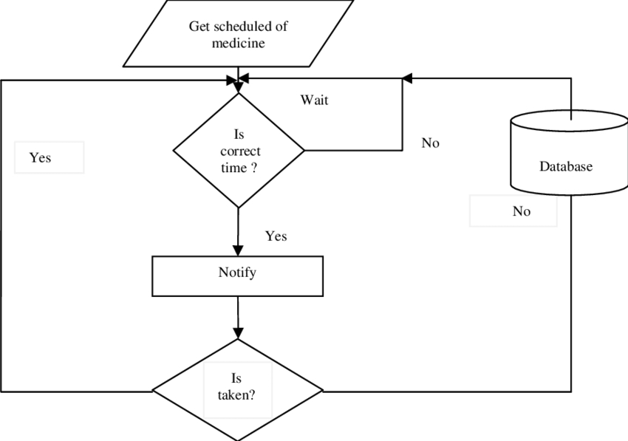to set for medication by using **INC** and **Next** button which is connected to pin 9 and 10

respectively of arduino. After set time 1, LCD shows **set Time 2.** Now using previous process set the time again. And after second time set, LCD shows again **set time 3**. And set this time like previous. In this system “Group medicine” indication (**take group 1 medicine, take group 2 medicine and take group 3 medicine**) is used instead of medicine name. When any alarm occurs LCD indicates **Group medicine 1, Group medicine 2, Group medicine 3.**MedicationMedication alarm time is also feed in **Arduino’s internal eeprom** to save from lose data after light failure. And real time is continuously checked with saved **Arduino’s internal eeprom**time. If any match occurs. LCD shows medication group name and buzzer starts beeping continuously. Buzzer is directly connected with pin number 13 of arduino for medication time indication.**16×2 LCD’s data pin D4, D3, D2, D2** are connected with**pin5, 4, 3, 2 of arduino.** And **command pin RS** and **EN** is directly connected with **pin 7, 6 of arduino**. **RW**pin of LCD is directly connected with ground.

**1.2 Purpose**

In modern society, most of the time people remain busy in their daily life schedule. It is true that they give more preference to their work than taking care of their health. Several diseases like diabetes, blood pressure is nowadays very common. Maintaining daily medication become very difficult for old people. Sometimes younger is faced with the same problem. There are many people in our family who need constant help may it be our elderly people, younger or others. But it is not always possible for us to remind them of their medicine’s dosages every time. For this purpose, there needs to be some facility for us which monitoring patient and take care. Nowadays we are all used to living technology-based life. We can use this technology in a way that will be beneficial for us. Cell phones aren’t best utilized for calling but now maybe used as an ensemble of embedded sensors that together allow new packages including human services, healthcare, social networks, environmental tracking etc. Today in medical services frameworks, the usage of cell phones is turning into an expanding number of values [1]. IoT may be helpful to monitor real-time condition and IoT can be a powerful and effective paradigm to store data collected by sensors devices to the cloud. In our project, the IoT enabled device will control the overall monitoring system. And developed an android application which help patients by reminding medicine in take time and so on

**CHAPTER 2**

**LITERATURE SURVEY**

**2.1 Existing problem**

Patients may often fail to comply with their medication whether it was from forgetting to take the medicine, from taking medicine at the wrong time or even from taking too much medicine. Sometimes elderly people forget to take their medicine at the correct time. They also forget which medicine He / She should take at that particular time. And it is difficult for doctors/caretakers to monitor the patients around the clock. To avoid this problem, this medicine reminder system is developed. Although the Internet of Things can be of great benefit to healthcare, there are still major challenges to address before full-scale implementation. The threats and disadvantages of using connected devices in healthcare are as follows:

1. **Security and privacy**: Security and privacy remain a major concern deterring users from using IoT technology for medical purposes, as[healthcare monitoring solutions](https://www.fpt-software.com/white-paper/healthcare-collaboration-monitoring-solutions/) have the potential to be breached or hacked. The leak of sensitive information about the patient’s health and location and meddling with sensor data can have grave consequences, which would counter the benefits of IoT.
2. **Risk of failure**: Failure or bugs in the hardware or even power failure can impact the performance of sensors and connected equipment placing healthcare operations at risk. In addition, skipping a scheduled software update may be even more hazardous than skipping a doctor checkup.
3. **Integration**: There’s no consensus regarding IoT protocols and standards, so devices produced by different manufacturers may not work well together. The lack of uniformity prevents full-scale integration of IoT, therefore limiting its potential effectiveness.
4. **Cost**: While IoT promises to reduce the cost of healthcare in the long-term, the cost of its implementation in hospitals and staff training is quite high.

**2.2 References**

1.A.  Sawand,  S.  Djahel,  Z.  Zhang,  and  F.  Na.  Multidisciplinary  Approaches  to Achieving Efficient  and  Trustworthy  e Health Monitoring Systems.  Commun .China  (ICCC), 2014 IEEE/CIC Int. Conf., pp. 187–192, 2014.

2. D. a. Clifton, D. Wong, L. Clifton, S. Wilson, R. Way, R. Pullinger, and L. Tarassenko. A large-scale  clinical  validation  of  an  integrated  monitoring  system  in  the Emergency Department. IEEE J. Biomed. Heal. Informatics vol. 17, no. 4, pp. 835–842, 2013.

3. M. Parida, H.-C.Yang, S.-W.Jheng, and C.-J. Kuo.Application of RFID Technology for In-House  Drug  Management  System.15th  Int.  Conf.Network-Based  Inf.  Syst.,  pp.  577–581, 2012.

4. L.  Ilkko  and  J.  Karppinen.UbiPILL  A  Medicine  Dose  Controller  of  Ubiquitous  Home Environment. 2009 Third Int. Conf. Mob. UbiquitousComput.Syst. Serv. Technol., pp. 329–333, 2009.

5. A.  Kliem,  M.  Hovestadt,  and  O.  Kao.Security  and  Communication  Architecture  for Networked Medical Devices in Mobility-Aware e Health Environments,” 2012  IEEE First Int. Conf. Mob. Serv., pp. 112–114, 2012.

6. S. T.-B. Hamida, E. Ben Hamida, B. Ahmed, and A. Abu-Dayya.Towards efficient and secure in-home  wearable  insomnia  monitoring  and diagnosis  system.13th  IEEE  Int.  Conf. Bioinforma. Bioeng., pp. 1–6, 2013.

7. P.  Ray.Home  Health  Hub  Internet of  Things  (H  3  IoT):  An  architectural  framework  for monitoring health of elderly people.Sci. Eng. Manag.Res, pp. 3–5, 2014.

8. S.  Huang,  H.  Chang,  Y.  Jhu,  and  G.  Chen.The  Intelligent  Pill  Box  -  Design  and Implementation.pp. 235–236, 2014.

9. F.-T.  Lin,  Y.-C.Kuo,  J.-C.Hsieh,  H.-Y.Tsai,  Y.-T.  Liao,  and  H. C.  Lee  A  Self-powering Wireless Environment Monitoring System Using  Soil Energy. IEEE Sens. J., vol. 15, no. c, pp. 1–1, 2015.

10. S. S. Al-majeed.HomeTelehealth by Internet of Things (IoT).pp. 609–613, 2015.

**2.3 Problem Statement Definition**

Patients may often fail to comply with their medication whether it was from forgetting to take the medicine, from taking medicine at the wrong time or even from taking too much medicine. Therefore, there are many systems such as reminder, alarm, and so on to remind patient. We have focus on those patients who having difficulty to take medication on time, we tried to design and to aid patients with managing their medical prescriptions, through a reminder app they will use to look at and manage their medications. The Pill Reminder will facilitate users to require the right medication on time. This system provides a real time monitoring system that allow related people to monitor the patient’s activity remotely.

**CHAPTER 3**

**IDEATION & PROPOSED SOLUTION**

**3.1 Empathy Map Canvas**

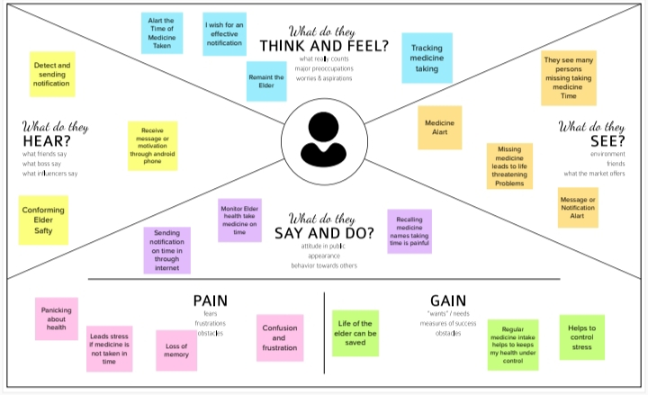

Fig 3.1.1 Empathy Map Canvas

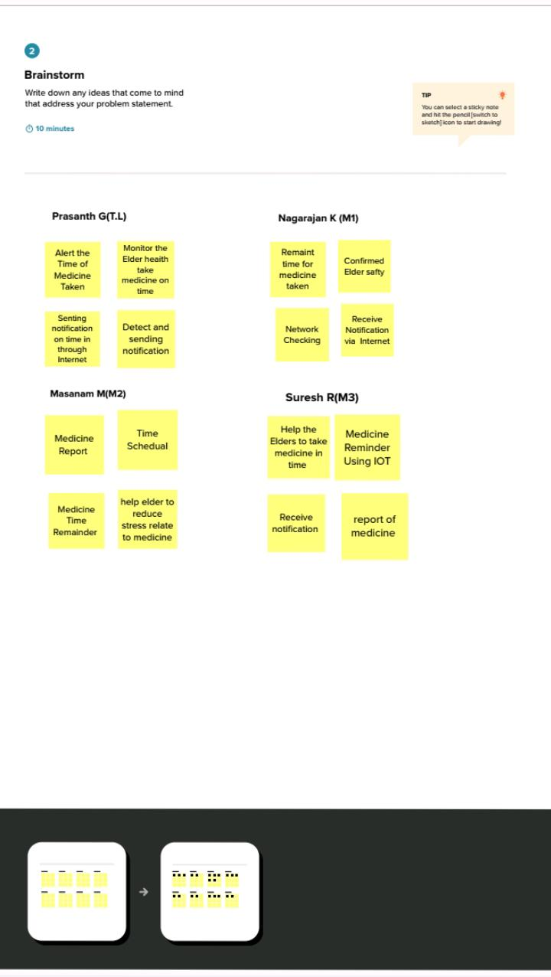**3.2 Ideation & Brainstorming**

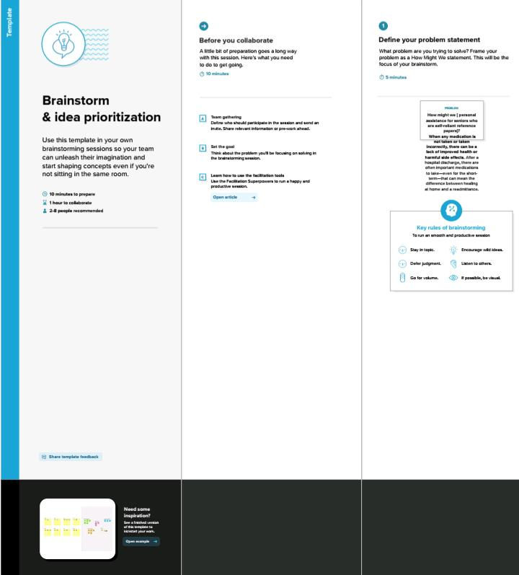

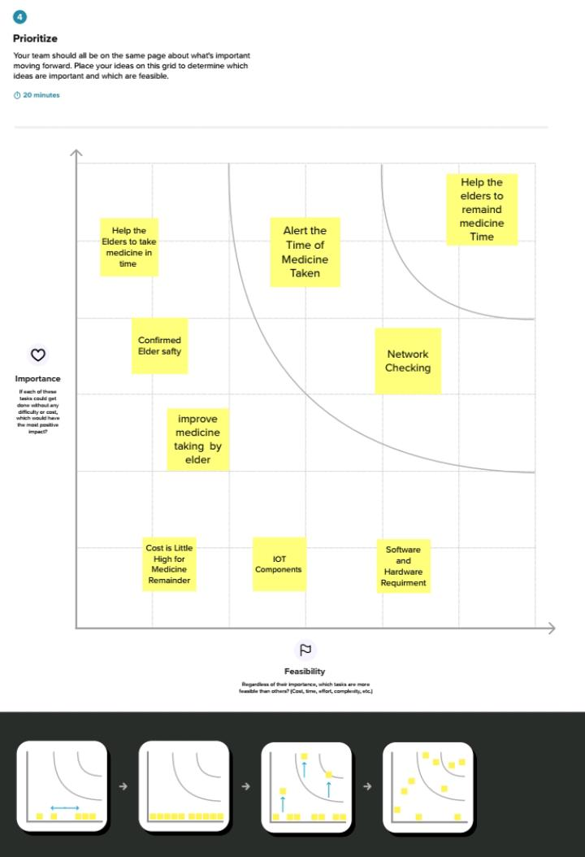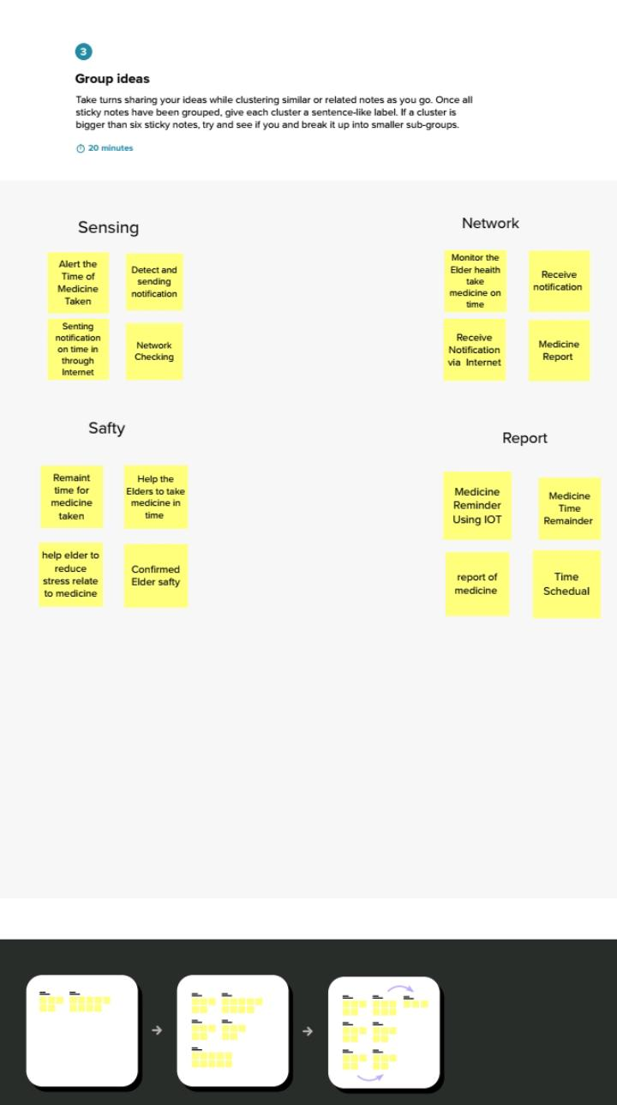

Fig 3.2.1 Ideation & Brainstorm

**3.3 Proposed Solution**

Here we introduce a smart medicine reminder system based on IoT. The proposed scheme was particularly created for the Android platform. For our system, we implement a reminder system which provides an alarm when it is time for taking medicine. Along with that, there is an android application where the user can set their medicine time. In the application, there will some feature that help the user to know more details about their medicine. It keeps track for the medicine which means how much medicine they have to take they can be fixed in the application. The device setup consists of an IoT enabled pill box having multiple compartments, each having a lid to open, and an IR sensor attached to it. The system of pill box includes of IR sensors for observance and reported the state of medication, that frequently checks whether the medicine is taken or not. Whenever the medication is loaded into the pillbox it’ll be updated the medicine data and saved in database. The Arduino device fetching real time data and send it to the application.

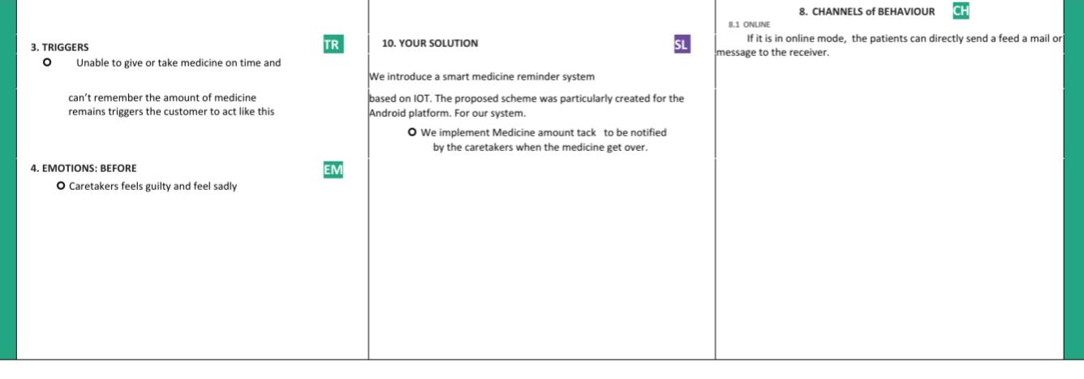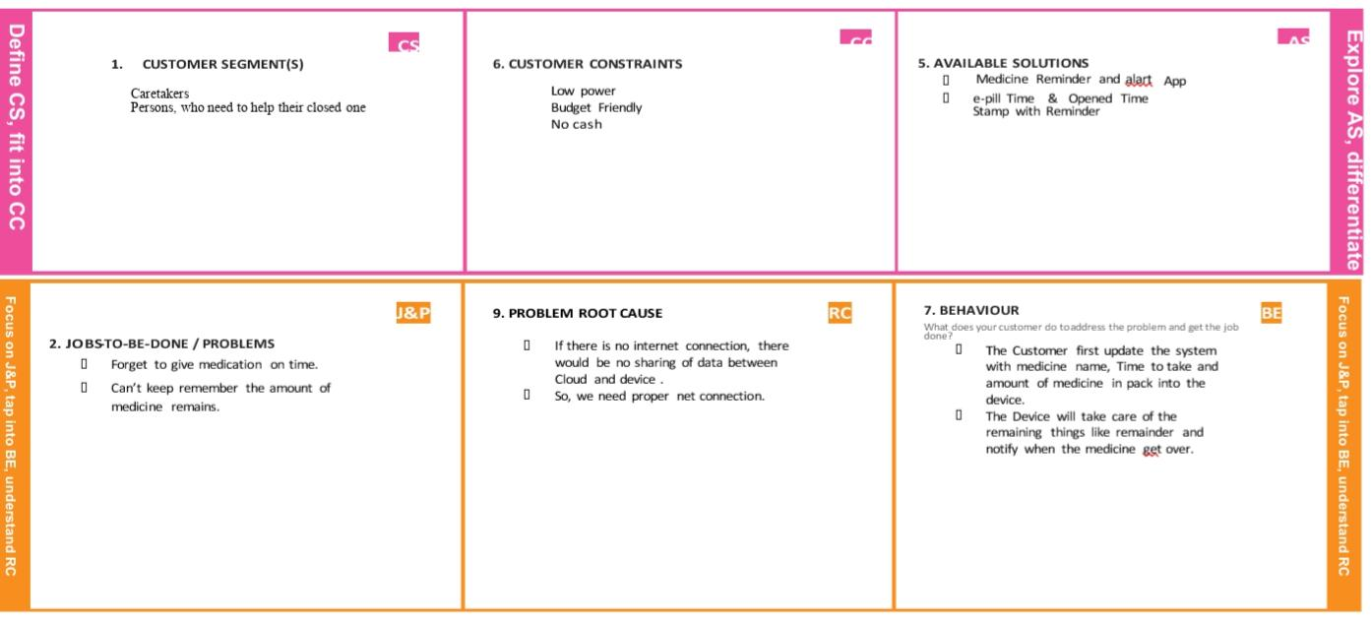**3.4 Problem Solution fit**

**.**

**CHAPTER 4**

**REQUIREMENT ANALYSIS**

In modern society, busy life has made people forget many things in day to day life. The elderly people and the people victims of chronicle diseases who need to take the medicines timely without missing are suffering from dementia, which is forgetting things in their daily routine. Considering this situation study has been done in this. Paper reviewing the technologies of home health care which are currently used for improving this situation by reminding the scheduled of medicine, remote monitoring and update new medicine data of patients, which can be done by prescriber through web.

**4.1 Functional requirement**

1. Tinkercat
2. Python IDLE
3. IBM Watson IoT Platform
4. Node-RED Service
5. Cloudant DB

**4.2 Non-Functional requirements**

1. Arduino Uno R3
2. LED(Green,Red,Blue)
3. 220Q Resistor
4. LCD 16x2
5. Piezo
6. 1 k ome Resistor
7. Positional Micro Servo

**Arduino Uno R3**

Arduino is an open source computer hardware and software company, project, and user community that designs and manufactures single-board microcontrollers and microcontroller kits for building digital devices and interactive objects that can sense and control objects in the physical and digital world.

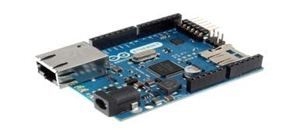

Fig 4.2.1 Arduino Uno R3

**LED(Green,Red,Blue)**

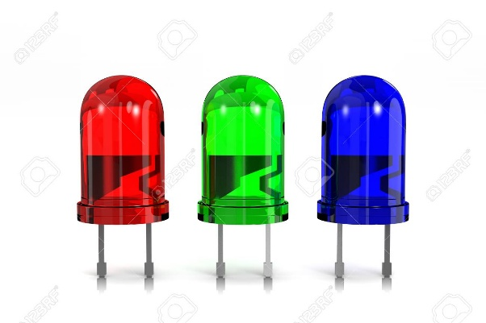 Fig 4.2.2 LED

LEDs (light-emitting diodes) are small, bright, power-efficient lights commonly used in electronic products. An LED light is a polarized part, meaning it has to be connected to a circuit in a certain way to work properly

**Resistor**

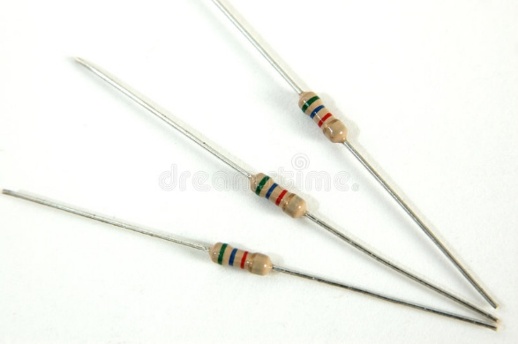

Fig 4.2.3 Resistor

resistor is a two-terminal electrical component that provides electrical resistance. In electronic circuits, resistors are predominantly used to lower the flow of current, divide voltages, block transmission signals, and bias active elements

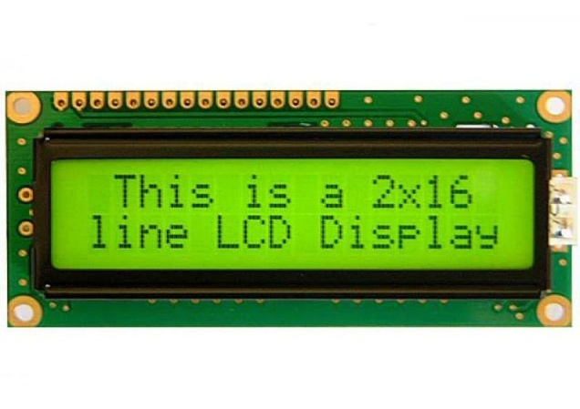**LCD 16x2**

Fig 4.2.4 LCD 16x2

16x2 LCD means it can display 16 characters per line and there are 2 such lines. In this LCD each character is displayed in 5x7 pixel matrix. The 16 x 2 intelligent alphanumeric dot matrix display is capable of displaying 224 different characters and symbols. This LCD has two registers, namely, Command and Data.

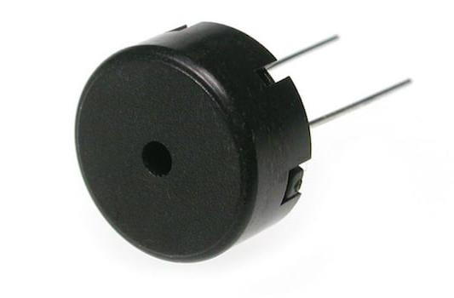**Piezo**

Fig 4.2.5 Piezo

Piezoelectric effect is extensively used to convert the electric energy into mechanical energy and vice-versa i.e. the piezoelectric substances are used as electromechanical transducers.

**Positional Micro Servo**

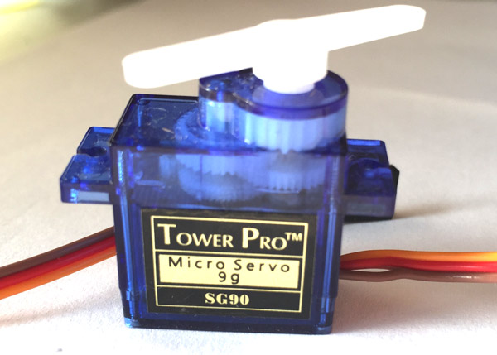 Fig 4.2.6 Positional Micro Servo

Servo motors or “servos”, as they are known, are electronic devices and rotary or linear actuators that rotate and push parts of a machine with precision. Servos are mainly used on angular or linear position and for specific velocity, and acceleration.

**CHAPTER 5**

**PROJECT DESIGN**

**5.1 Data Flow Diagrams**

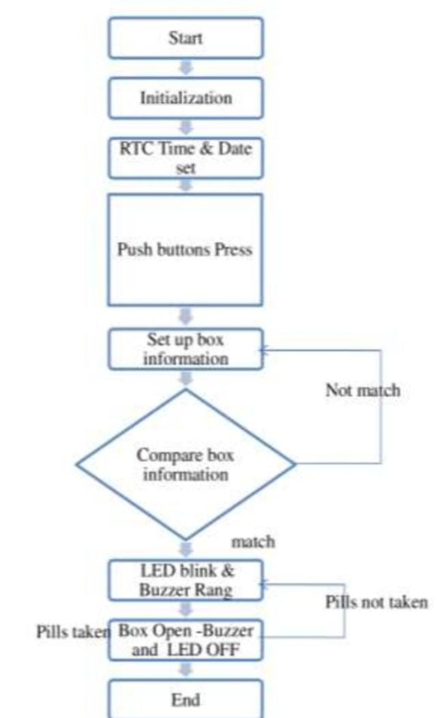**Architecture:**

Fig 5.1.1 Data Flow Diagram

A Data Flow Diagram (DFD) is a traditional visual representation of the information flows within a system. A neat and clear DFD can depict the right amount of the system requirement graphically. It shows how data enters and leaves the system, what changes the information, and where data is stored.

**5.2 Solution & Technical Architecture**

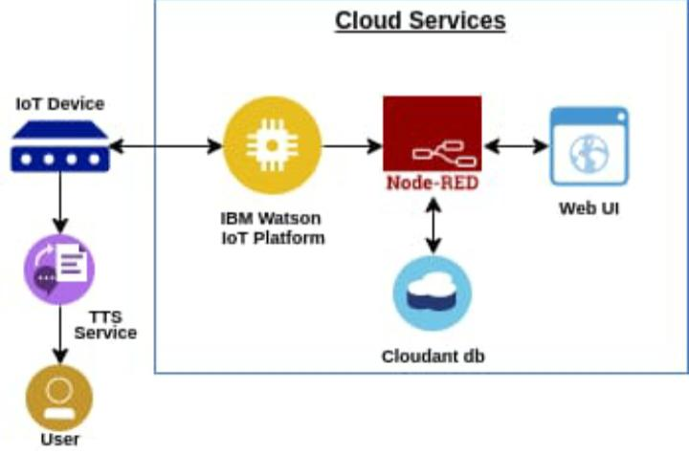

Fig 5.2.1 Technical Architecture

Technology architecture provides a more concrete view of the way in which application components will be realized and deployed. It enables the migration problems that can arise between the different steps of the IS evolution path to be studied earlier.

**5.3 User Stories**

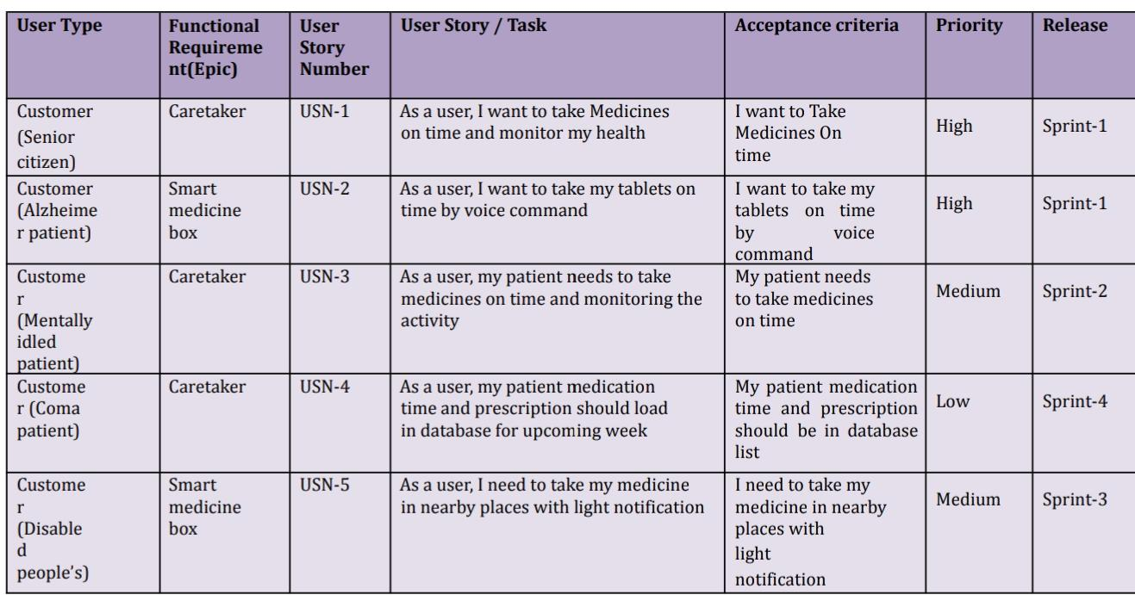

Fig 5.3.1 User Stores

**CHAPTER 6**

**PROJECT DESIGN**

**6.1 Sprint Planning & Estimation**

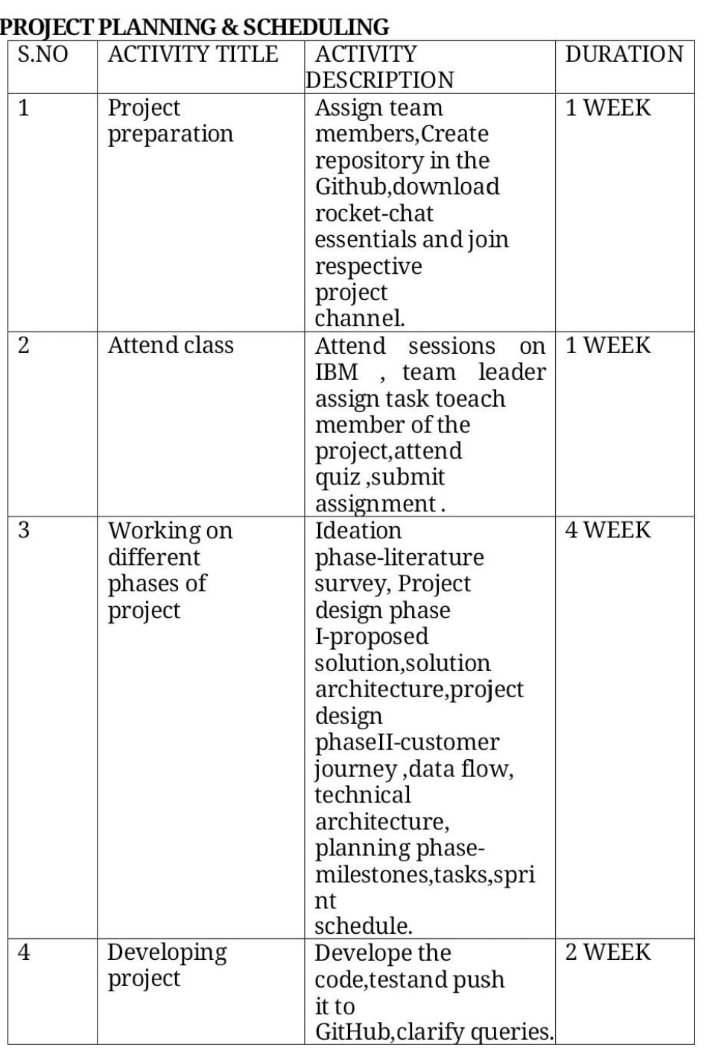

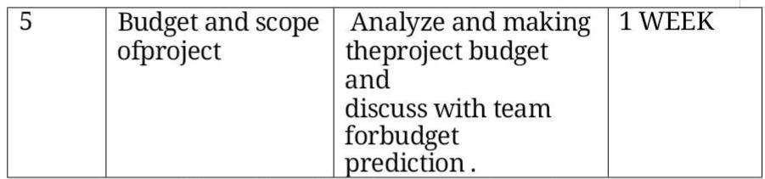

Fig 6.1.1 Table Sprint Planning And Estimation

**6.2 Sprint Delivery Schedule**

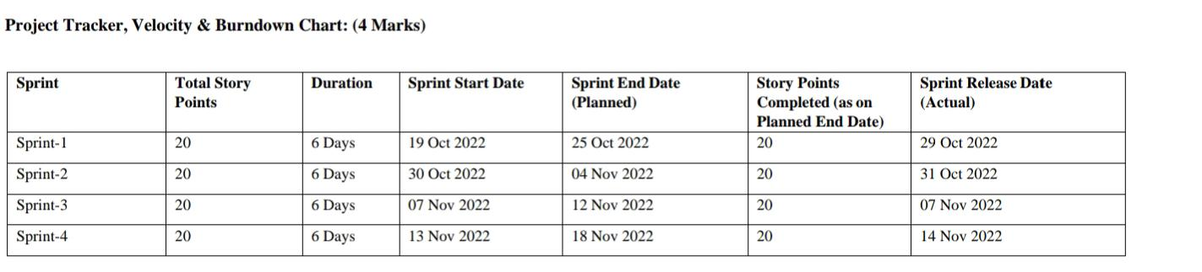

Fig 6.2.1 Sprint Delivery Schedule

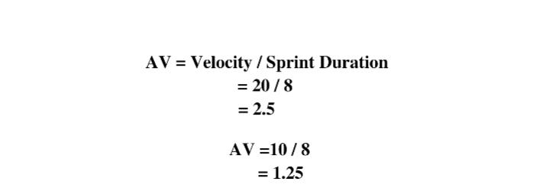**6.3 Burndown Char**

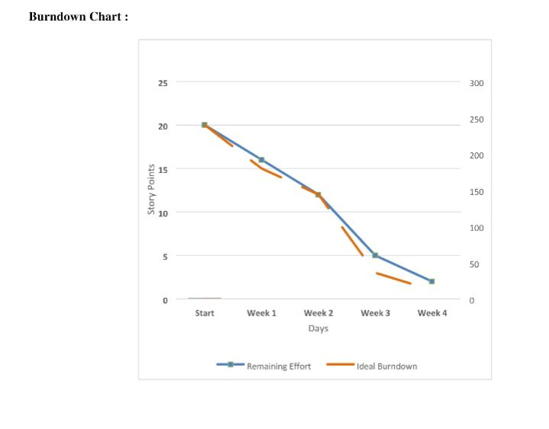

Fig 6.3.1 table sprint planning and estimation

**CHAPTER 7**

**CODING & SOLUTIONING**

**7.1 Feature 1**

In the feasibility study, not all of reminders were effective for patients to take their medication in case they were away from the smartphone or they did not notice the small sound of reminders. We would design and improve reminders to repeat second or third time in user’s favorite interval, to display some messages about reminders on the smartphone until the patient inputs records of medication-taking, or to send a reminder to their home phone.If someone else is taking an active part in helping to manage user’s medications, then they prefer an app with a number of collaboration features. MyTherapy measures and stores vitals, keeps medication usage history with the ability to print personal health report and share results with a doctor or family members.Care Zone uses the camera to take pictures of important documents and save them. The app helps to organize key contacts including doctors, pharmacies, insurance, and family members to safely share access to coordinate care.

**7.2 Feature 2**

**One of the wonders of modern medicine are the wide variety of medications that enhance both the quality and length of our lives. Today medicine is used to control blood pressure, insulin, cholesterol and even the rate at which our hearts beat. Yet medicines are both a godsend and a curse. If prescribed and managed properly they work. If not, then they are not effective and can even result in hospitalization or death. This is why having a medication reminder system that works is very important to your health. It is also important to “brown bag” your medications from time to time as part of good medication management practices. Medication reminder systems must include more than a nudge to take the medication at the right time. They must also include knowledge of how you need to take the medication. Does it need to be taken with food or on an empty stomach? Do you need to avoid certain foods or drinks while taking it? For instance, many medications require that you avoid drinking grapefruit juice. Other medication may require you to abstain from drinking alcohol. Some work better if you take them before you go to bed, and so on. Your medication reminder system must include this information. If you are taking fewer than six medications daily, you may be able to commit information on how to take your medication to memory, such as remembering to take Metformin with every meal. However, no matter how many medications you take nearly everyone can benefit from a medication reminder system.**

**CHAPTER 8**

**TESTING**

**8.1 TEST CASES**

Software testing follows a common process. Tasks or steps include defining the test environment, developing test cases, writing scripts, analyzing test results and submitting defect reports. Testing can be time-consuming. Manual testing or ad-hoc testing may be enough for small builds. However, for larger systems, tools are frequently used to automate tasks. Automated testing helps teams implement different scenarios, test differentiators (such as moving components into a cloud environment), and quickly get feedback on what works and what doesn’t. A good testing approach encompasses the application programming interface (API), user interface and system levels. As well, the more tests that are automated, and run early, the better. Some teams build in-house test automation tools

A test case is a defined format for software testing required to check if a particular application/software is working or not. A test case consists of a certain set of conditions that need to be checked to test an application or software i.e. in more simple terms when conditions are checked it checks if the resultant output meets with the expected output or not. A test case consists of various parameters such as Id, condition, steps, input, expected result, result, status, and remarks.

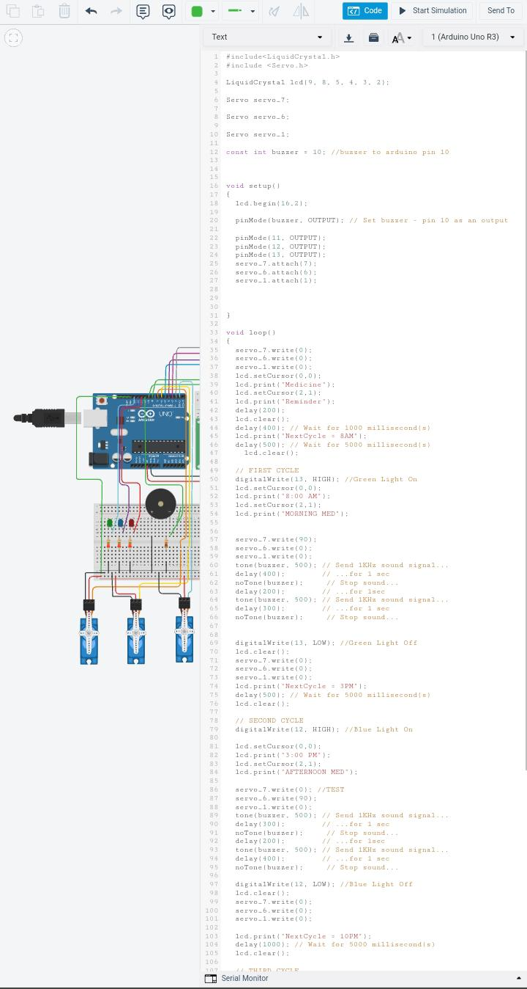

**8.2 User Acceptance Testing**

once software has undergone Unit, Integration and System testing because developers might have built software based on requirements document by their own understanding and further required changes during development may not be effectively communicated to them, so for testing whether the final product is accepted by client/end-user, user acceptance testing is needed.

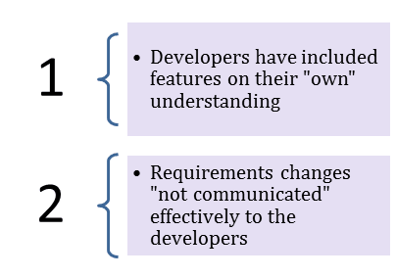

* Developers code software based on requirements document which is their “own” understanding of the requirements and **may not actually be what the client needs from the software**.
* Requirements changes during the course of the project may not be communicated effectively to the developers

User Acceptance Testing (UAT), which is performed on most UIT projects, sometimes called beta testing or end-user testing, is a phase of software development in which the software is tested in the "real world" by the intended audience or business representative.

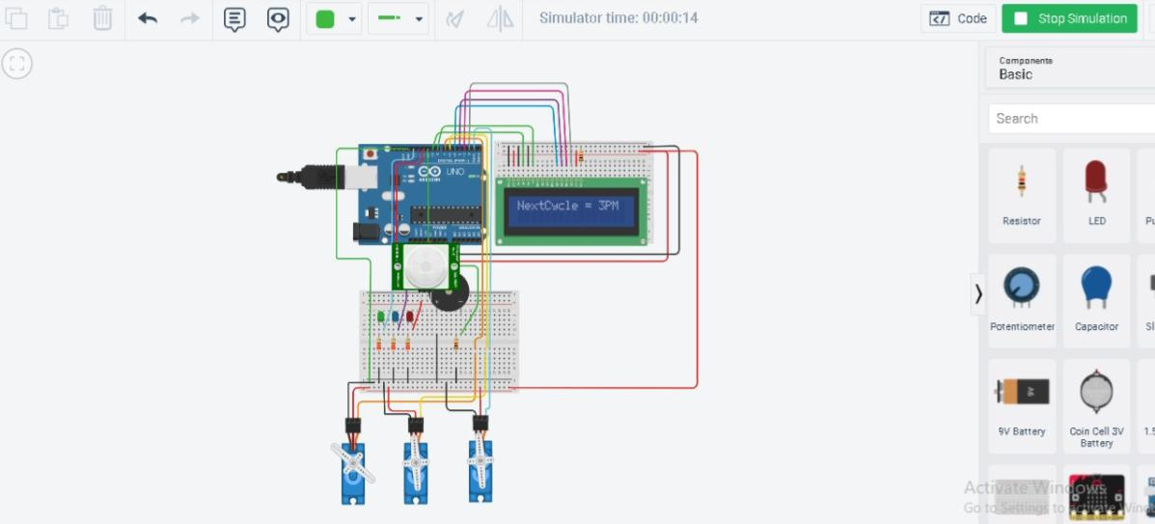

**CHAPTER 9**

**RESULT**

**9.1 Performance Metrics**

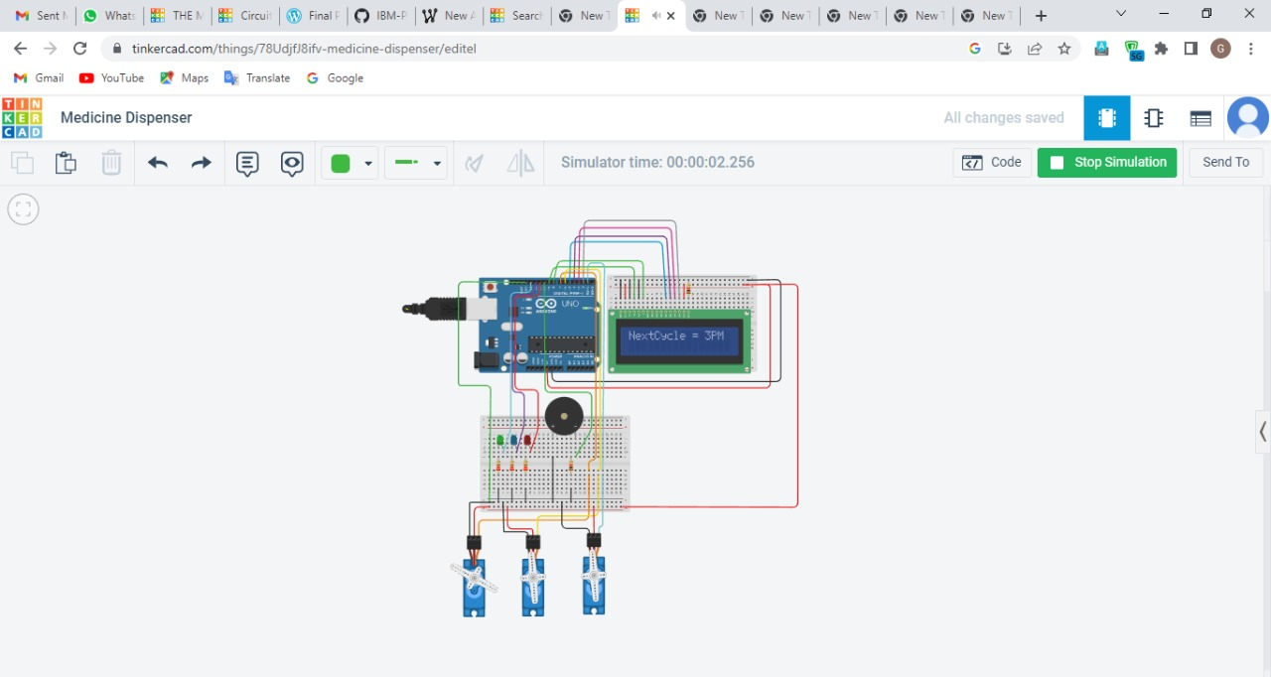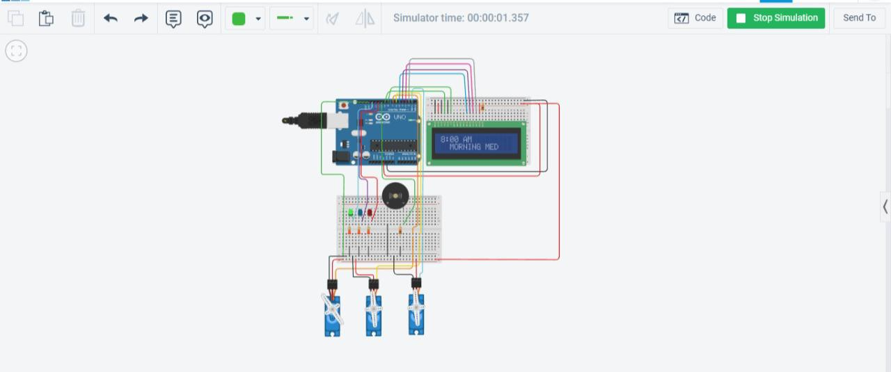Performance metrics are data used to track processes within a business. This is achieved using activities, employee behavior, and productivity as key metrics. These metrics are then used by employers to evaluate performance. This is in relation to an established goal such as employee productivity or sales objectives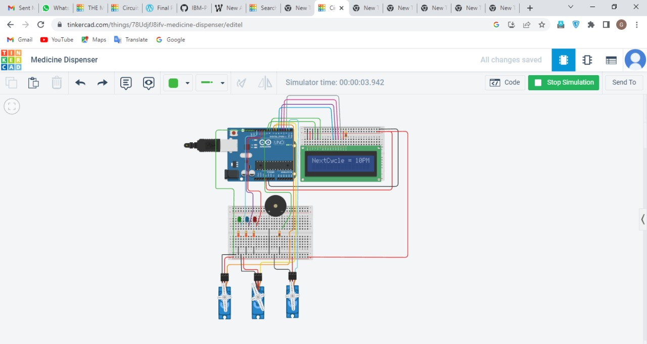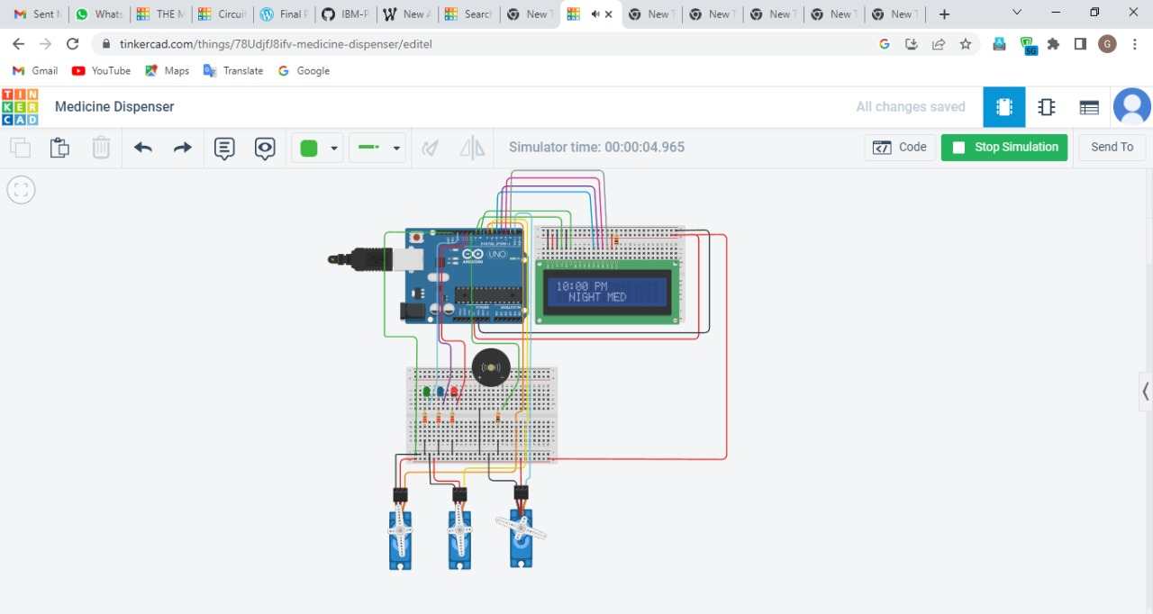

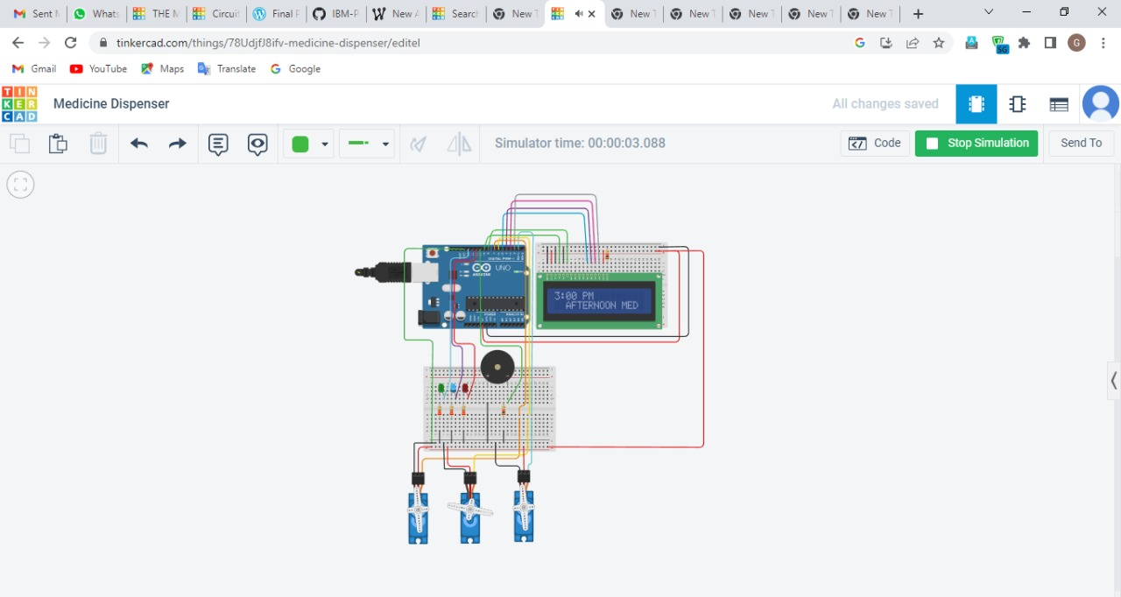

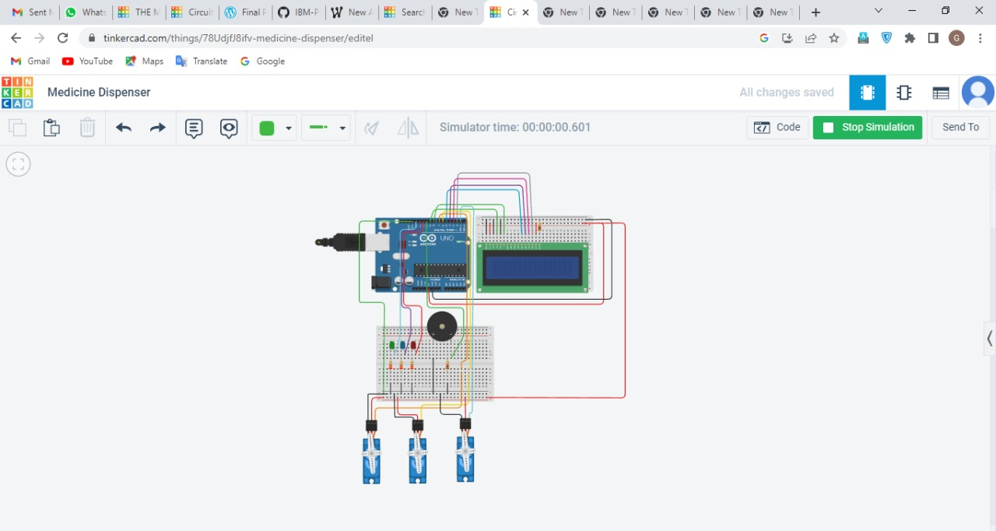

**CHAPTER 10**

**ADVANTAGES & DISADVANTAGES**

**ADVANTAGES**

* medication reminder and organizer can help to prevent these life-threatening mistakes. They remind your loved one to take the right medication at the right time. Medication reminders are an important piece of any aging in place plan
* **Reminds Your Senior to Take Their Medication**
* **Prevent Errors**

It is easy for seniors to take the wrong meds or even skip doses. Medication reminders prevent this from happening. There is nothing your senior has to read or figure out. They simply need to take the pills in the compartment after the reminder beeps.

* **Easy to Use**
* **Be Proactive**

By giving your loved one a medication reminder, you are also giving them greater health and independence. Help them age in place with the right tools to help them stay safe a healthy

**DISADVANTAGES**

* Cost Efficient
* Power supply problems
* Circuit Cost High
* Maintenance Cost High

**CHAPTER 11**

**CONCLUSION**

**CONCLUSION**

Hence an attempt was made to build a medicine reminder kit which gives indication at

proper time and also an alert to pre-guardian about tablet consumption status.

Medicine reminder apps and devices which are a part of IoT, increases adherence to treatment thus achieves better control of disease and reduces complications. Wearable devices can monitor parameters of a person like heart rate, blood oxygen, body temperature, blood pressure, ECG. These parameters are crucial for maintaining health of the individual. Shortage of skilled human resources in health sector can be addressed by this technology. Best of health services with more precision can be provided in remote areas of country. Hence use of IoT in medical field is a boon.

**CHAPTER 12**

**FUTURE SCOPE**

**Future Scope**

There are several aspects we need to work on our device in the future to meet the user needs. Firstly, we should develop strategies and modify the device based on the user evaluation results. This includes creating a user manual; choosing a larger lcd display; using a metal or plastic box to cover the entire circuitry; placing the switch and led displays on the surface of thebox and using larger pill boxes.We should also follow the risk analysis structure to analyze the potential risks and hazards as well as develop strategies to mitigate the risks.

**CHAPTER 12**

**APPENDIX**

**Source Code**

**#include<LiquidCrystal.h>**

**#include <Servo.h>**

**LiquidCrystal lcd(9, 8, 5, 4, 3, 2);**

**Servo servo_7;**

**Servo servo_6;**

**Servo servo_1;**

**const int buzzer = 10; //buzzer to arduino pin 10**

**void setup()**

**{**

**lcd.begin(16,2);**

**pinMode(buzzer, OUTPUT); // Set buzzer - pin 10 as an output**

**pinMode(11, OUTPUT);**

**pinMode(12, OUTPUT);**

**pinMode(13, OUTPUT);**

**servo_7.attach(7);**

**servo_6.attach(6);**

**servo_1.attach(1);**

**}**

**void loop()**

**{**

**servo_7.write(0);**

**servo_6.write(0);**

**servo_1.write(0);**

**lcd.setCursor(0,0);**

**lcd.print("Medicine");**

**lcd.setCursor(2,1);**

**lcd.print("Reminder");**

**delay(200);**

**lcd.clear();**

**delay(400); //**

**lcd.print("NextCycle = 8AM");**

**delay(500); // Wait for 500 millisecond(s)**

**lcd.clear();**

**// FIRST CYCLE**

**digitalWrite(13, HIGH); //Green Light On**

**lcd.setCursor(0,0);**

**lcd.print("8:00 AM");**

**lcd.setCursor(2,1);**

**lcd.print("MORNING MED");**

**servo_7.write(90);**

**servo_6.write(0);**

**servo_1.write(0);**

**tone(buzzer, 500); // Send 1KHz sound signal...**

**delay(400);**

**noTone(buzzer); // Stop sound...**

**delay(200);**

**tone(buzzer, 500); // Send 1KHz sound signal...**

**delay(300);**

**noTone(buzzer); // Stop sound...**

**digitalWrite(13, LOW); //Green Light Off**

**lcd.clear();**

**servo_7.write(0);**

**servo_6.write(0);**

**servo_1.write(0);**

**lcd.print("NextCycle = 3PM");**

**delay(500); // Wait for 500 millisecond(s)**

**lcd.clear();**

**// SECOND CYCLE**

**digitalWrite(12, HIGH); //Blue Light On**

**lcd.setCursor(0,0);**

**lcd.print("3:00 PM");**

**lcd.setCursor(2,1);**

**lcd.print("AFTERNOON MED");**

**servo_7.write(0); //TEST**

**servo_6.write(90);**

**servo_1.write(0);**

**tone(buzzer, 500); // Send 1KHz sound signal...**

**delay(300);**

**noTone(buzzer); // Stop sound...**

**delay(200);**

**tone(buzzer, 500); // Send 1KHz sound signal...**

**delay(400);**

**noTone(buzzer); // Stop sound...**

**digitalWrite(12, LOW); //Blue Light Off**

**lcd.clear();**

**servo_7.write(0);**

**servo_6.write(0);**

**servo_1.write(0);**

**lcd.print("NextCycle = 10PM");**

**delay(1000);**

**lcd.clear();**

**// THIRD CYCLE**

**digitalWrite(11, HIGH); //Red Light On**

**lcd.setCursor(0,0);**

**lcd.print("10:00 PM");**

**lcd.setCursor(2,1);**

**lcd.print("NIGHT MED");**

**servo_7.write(0); //TEST**

**servo_6.write(0);**

**servo_1.write(90);**

**tone(buzzer, 500); // Send 1KHz sound signal...**

**//delay(1000); //**

**noTone(buzzer); // Stop sound...**

**delay(200); //**

**tone(buzzer, 500); // Send 1KHz sound signal..**

**delay(300);**

**noTone(buzzer); // Stop sound...**

**digitalWrite(11, LOW); //Red Light Off**

**lcd.clear();**

**servo_7.write(0);**

**servo_6.write(0);**

**servo_1.write(0);**

**delay(200);**

**}**

**GitHub & Project Demo Link**

**GitHub Link :** [**https://github.com/IBM-EPBL/IBM-Project-45774-1660732277**](https://github.com/IBM-EPBL/IBM-Project-45774-1660732277)

**Project Demo Link: (Drive Link)** [**https://drive.google.com/file/d/1Gy1Qfg3LQRfb33WBXJKyTtw07cIr8qIa/view?usp=drivesdk**](https://drive.google.com/file/d/1Gy1Qfg3LQRfb33WBXJKyTtw07cIr8qIa/view?usp=drivesdk)

**Project Demo Link: ( YouTube Link).**  [**https://youtu.be/FgyPqz9WEf4**](https://youtu.be/FgyPqz9WEf4)